**DIESEASE PREDICTION**

**1.Importing libraries:**

import numpy as np

import pandas as pd

import matplotlib.pyplot as plt

import seaborn as sns

from sklearn.svm import SVC

from sklearn.model_selection import train_test_split,cross_val_score

from sklearn.metrics import accuracy_score,confusion_matrix,classification_report

from sklearn.preprocessing import LabelEncoder

from sklearn.naive_bayes import GaussianNB

from sklearn.ensemble import RandomForestClassifier

from scipy.stats import mode

from collections import Counter

%matplotlib inline

import warnings

warnings.filterwarnings("ignore")

**2.Load the Dataset:**

Reading the train.csv by removing the last column since it an empty column

df = pd.read_csv("/content/Training.csv").dropna(*axis* = 1)

df.head()

**3. Checking whether the dataset is balanced or not:**

disease_counts = df["prognosis"].value_counts()

disease_counts

temp_df = pd.DataFrame({

    "Disease": disease_counts.index,

    "Counts": disease_counts.values

})

plt.figure(*figsize* = (18,8))

sns.barplot(*x* = "Disease", *y* = "Counts", *data* = temp_df)

plt.xticks(*rotation*=90)

plt.show()

**Output:**

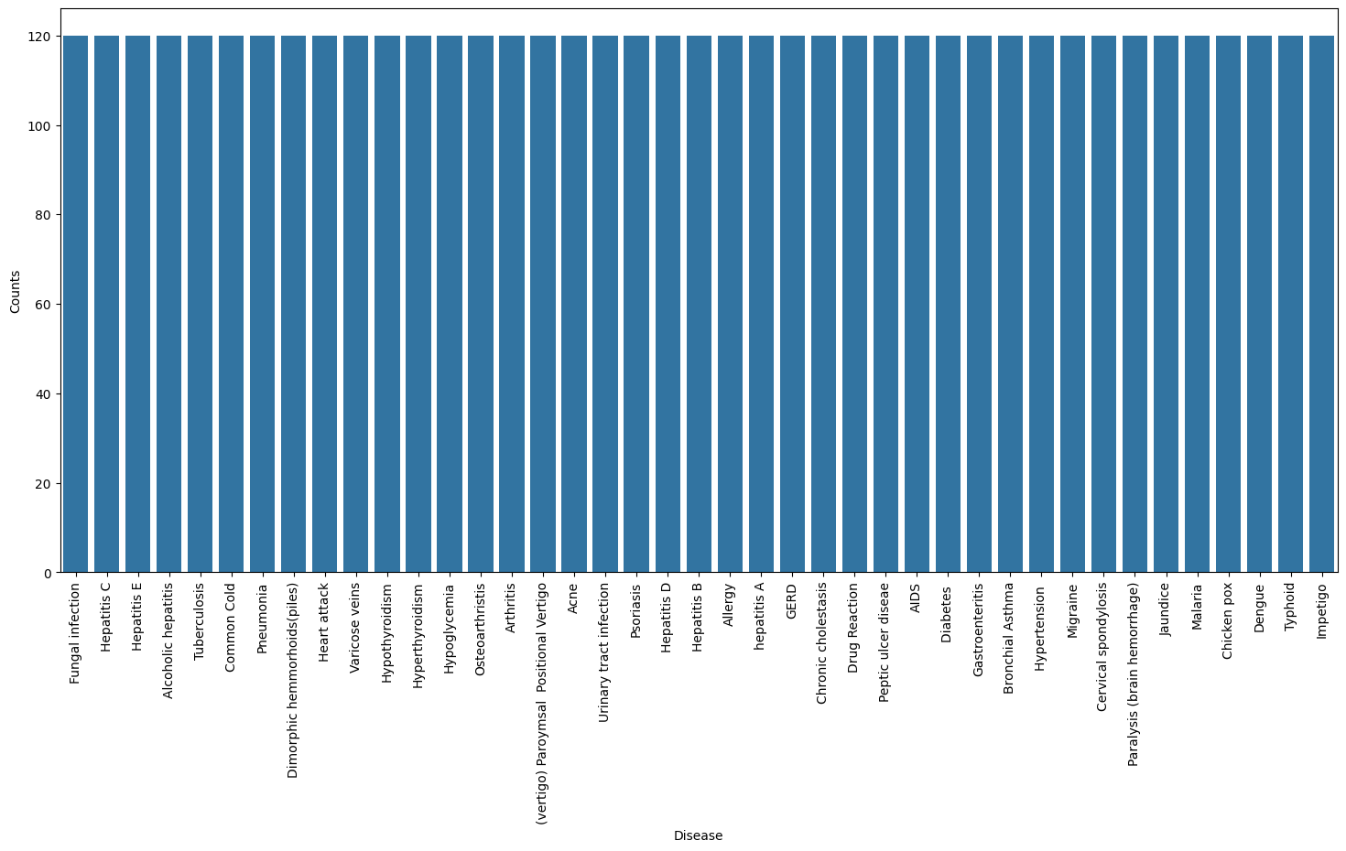

**4.** **Encoding the target value into numerical:**

encoder = LabelEncoder()

df["prognosis"] = encoder.fit_transform(df["prognosis"])

**5.Splitting the data for training and testing the model:**

X = df.drop("prognosis",*axis* = 1)

y = df["prognosis"]

print(X.shape)

print(y.shape)

Output:

(4920, 132)

(4920,)

X_train,X_test,y_train,y_test = train_test_split(X,y,*test_size* = 0.2,*random_state* = 24)

print(f"Train: {X_train.shape}, {y_train.shape}")

print(f"Test: {X_test.shape}, {y_test.shape}")

Output:

Train: (3936, 132), (3936,)

Test: (984, 132), (984,)

**6.Defining scoring metric for k-fold cross validation:**

def *cv_scoring*(*estimator*, *X*, *y*):

  return accuracy_score(y, estimator.predict(X))

models = {

    "SVC":SVC(),

    "Guassian NB":GaussianNB(),

    "Random Forest":RandomForestClassifier(*random_state* = 18)

}

**7.Producing cross validation score for the models:**

**for** model_name **in** models:

    model =models[model_name]

    scores =cross_val_score(model, X, y, *cv* =10,

*n_jobs* =-1,

*scoring* =cv_scoring)

print("=="*30)

print(model_name)

print(f"Scores: {scores}")

print(f"Mean Score: {np.mean(scores)}")

Output:

============================================================

Random Forest

Scores: [1. 1. 1. 1. 1. 1. 1. 1. 1. 1.]

Mean Score: 1.0

**8. Training and testing SVM Classifier:**

svm_model =SVC()

svm_model.fit(X_train, y_train)

preds =svm_model.predict(X_test)

print(f"Accuracy on test data by SVM Classifier: {accuracy_score(y_test, preds)*100}")

cf_matrix =confusion_matrix(y_test, preds)

plt.figure(*figsize*=(12,8))

sns.heatmap(cf_matrix, *annot*=True)

plt.title("Confusion Matrix for SVM Classifier on Test Data")

plt.show()

Output:

Accuracy on test data by SVM Classifier: 100.0

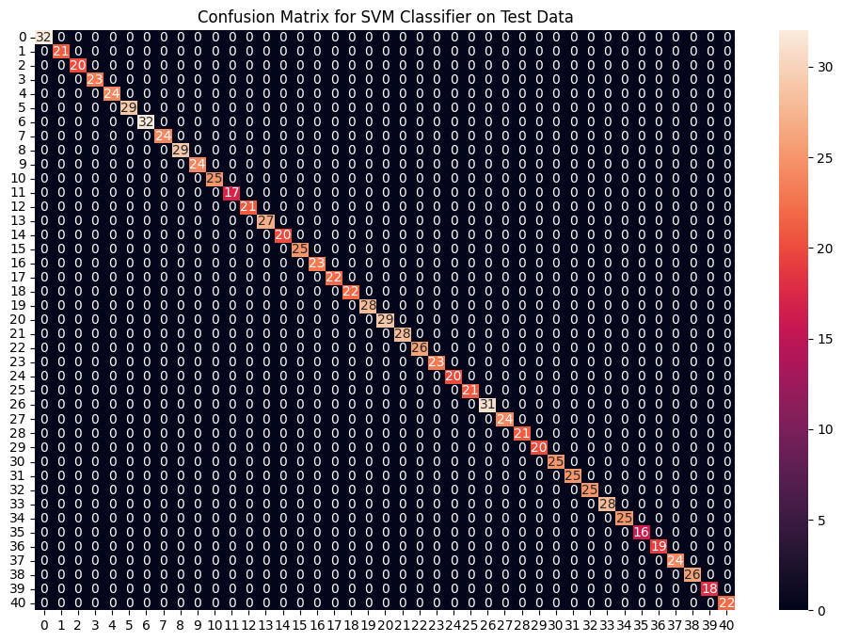

**9.Training and testing Naive Bayes Classifier:**

nb_model =GaussianNB()

nb_model.fit(X_train, y_train)

preds =nb_model.predict(X_test)

print(f"Accuracy on train data by Naive Bayes Classifier: {accuracy_score(y_train, nb_model.predict(X_train))*100}")

print(f"Accuracy on test data by Naive Bayes Classifier: {accuracy_score(y_test, preds)*100}")

cf_matrix =confusion_matrix(y_test, preds)

plt.figure(*figsize*=(12,8))

sns.heatmap(cf_matrix, *annot*=True)

plt.title("Confusion Matrix for Naive Bayes Classifier on Test Data")

plt.show()

**Output:**

Accuracy on train data by Naive Bayes Classifier: 100.0

Accuracy on test data by Naive Bayes Classifier: 100.0

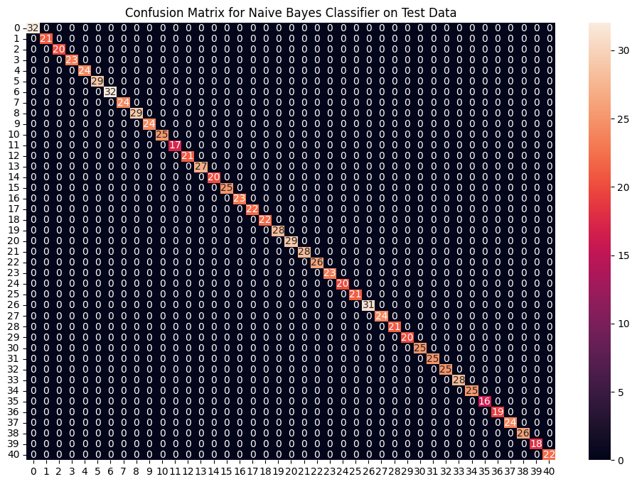

**10.Training and testing Random Forest Classifier**

rf_model =RandomForestClassifier(*random_state*=18)

rf_model.fit(X_train, y_train)

preds =rf_model.predict(X_test)

print(f"Accuracy on train data by Random Forest Classifier: {accuracy_score(y_train, rf_model.predict(X_train))*100}")

print(f"Accuracy on test data by Random Forest Classifier: {accuracy_score(y_test, preds)*100}")

cf_matrix =confusion_matrix(y_test, preds)

plt.figure(*figsize*=(12,8))

sns.heatmap(cf_matrix, *annot*=True)

plt.title("Confusion Matrix for Random Forest Classifier on Test Data")

plt.show()

Output:

Accuracy on train data by Random Forest Classifier: 100.0

Accuracy on test data by Random Forest Classifier: 100.0

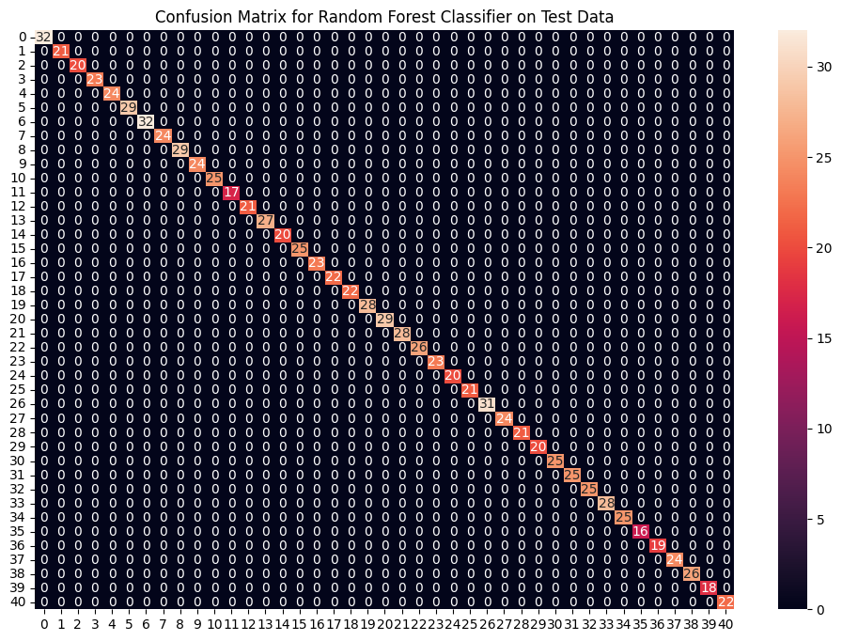

**11.Fitting the model on whole data and validating on the Test dataset**:

final_svm_model =SVC()

final_nb_model =GaussianNB()

final_rf_model =RandomForestClassifier(*random_state*=18)

final_svm_model.fit(X, y)

final_nb_model.fit(X, y)

final_rf_model.fit(X, y)

**12. Reading the test data:**

test_data = pd.read_csv(r"D:\Data_science\Practice_files\Diseases_Training_data.csv").dropna(*axis*=1)

# Separate features (test_X) and target labels (test_Y)

test_X = test_data.iloc[:, :-1]

test_Y = encoder.transform(test_data.iloc[:, -1])

**13.Making prediction by take mode of predictions:**

svm_preds = final_svm_model.predict(test_X)

nb_preds = final_nb_model.predict(test_X)

rf_preds = final_rf_model.predict(test_X)

# Stack the predictions vertically

all_preds = np.vstack((svm_preds, nb_preds, rf_preds))

**14.Compute the mode along the first axis (axis=0)**

mode_preds, _ = mode(all_preds, *axis*=0)

y_preds = mode_preds.flatten()

print(f"Accuracy on Test dataset by the combined model",{accuracy_score(test_Y, y_preds)*100})

cf_matrix = confusion_matrix(test_Y, y_preds)

plt.figure(*figsize*=(12,8))

sns.heatmap(cf_matrix, *annot* = True)

plt.title("Confusion Matrix for Combined Model on Test Dataset")

plt.show()

Output:

Accuracy on Test dataset by the combined model {100.0}

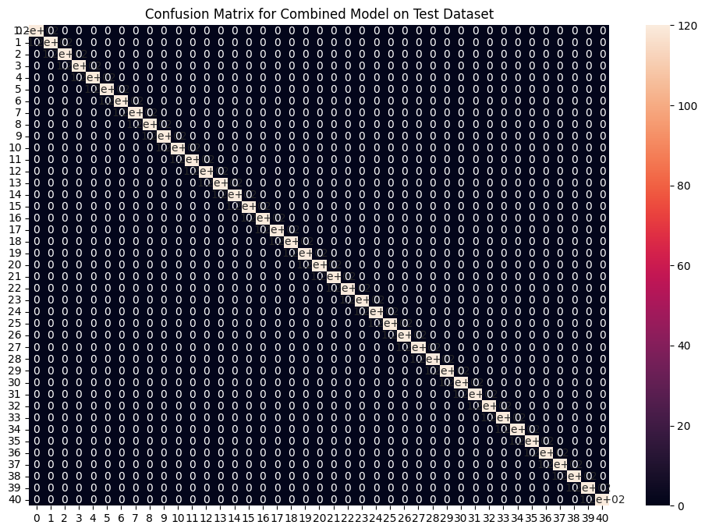

# Symptoms columns and encoding dictionary

symptoms = X.columns.values

# Creating a symptom index dictionary to encode the input symptoms into numerical form

symptom_index = {}

**for** index, value **in** enumerate(symptoms):

    symptom = " ".join([i.capitalize() **for** i **in** value.split("_")])

    symptom_index[symptom] = index

data_dict = {

    "symptom_index": symptom_index,

    "predictions_classes": encoder.classes_

}

# Defining the Function

# Input: string containing symptoms separated by commas

# Output: Generated predictions by models

def *predictDisease*(*symptoms*):

    symptoms = symptoms.split(",")

    # Creating input data for the models

    input_data = [0] * len(data_dict["symptom_index"])

**for** symptom **in** symptoms:

        symptom = symptom.strip()  # Ensure there's no leading/trailing whitespace

        index = data_dict["symptom_index"].get(symptom, None)

**if** index is not None:

            input_data[index] = 1

    # Reshaping the input data and converting it into a suitable format for model predictions

    input_data = np.array(input_data).reshape(1, -1)

    # Generating individual outputs

    rf_prediction = data_dict["predictions_classes"][final_rf_model.predict(input_data)[0]]

    nb_prediction = data_dict["predictions_classes"][final_nb_model.predict(input_data)[0]]

    svm_prediction = data_dict["predictions_classes"][final_svm_model.predict(input_data)[0]]

    # Making final prediction by taking mode of all predictions

    final_prediction = Counter([rf_prediction, nb_prediction, svm_prediction]).most_common(1)[0][0]

    predictions = {

        "rf_model_prediction": rf_prediction,

        "naive_bayes_prediction": nb_prediction,

        "svm_model_prediction": svm_prediction,

        "final_prediction": final_prediction

    }

**return** predictions

# Testing the function

print(predictDisease("Itching,Skin Rash,Nodal Skin Eruptions"))

Output:

{'rf_model_prediction': 'Fungal infection', 'naive_bayes_prediction': 'Fungal infection', 'svm_model_prediction': 'Fungal infection', 'final_prediction': 'Fungal infection'}